**Data-Driven Strategies for Improving Bus Service Consistency for International Students in Bristol, United Kingdom**

K. Do

University of the West of England, Bristol

Master of Data Science Dissertation

UFCF9Y-60-M - Csct masters project 23sep_1 ft

Student ID 23046466

[Artefact, Video, and Progress Reflective Report URL](https://uweacuk-my.sharepoint.com/:f:/g/personal/ky2_do_live_uwe_ac_uk/EiALeHevJS5Dr5MnaNbktawBesOrCm8OkQ1YY0exG39PLA?e=2uT6r9)

Passcode: AgeRLIMinO

Table of Contents

Abstract 5

Data-Driven Strategies for Improving Bus Service Consistency for International Students in Bristol, United Kingdom 6

Introduction 6

Background and Context 6

Problem Statement 6

Objectives and Scopes 7

Structure of the Dissertation 7

**Literature Review** 9

Public Transport Reliability 9

Challenges for International Students 9

Gap in the Research 10

Research Justification 11

Methodology 12

Data Collection and Processing 12

Location Data - SIRI packages 12

Timetable Data - TxC Packages 13

Mapping the SIRI and TXC Data 15

Route Reconstruction and Analysis Techniques 15

Map-Matching Raw GPS Data 16

Signal Cluttering Issue 16

Time-Distance Analysis 18

Performance Metric Definitions 18

Trip General Information 18

Trip Geographical Consistency 19

Trip Punctuation for Key Stations 20

Analysis and Result 21

Preliminary Raw Data Quality Analysis 21

Overall Line Performance 23

Case Study: Route Adherence Analysis for Line m1 26

Overview 26

Diversion Frequency and Severity 26

One-Segment Diversions 27

Moderate and Extreme Diversion Cases 27

Case Study: Time Consistency Analysis for Line 72, m3 and m4 29

Overview 29

Line 72 - Inbound 29

Line m3 - Inbound 30

Line m4 - Outbound 31

Analysis and Case Study Summary 32

**Discussion** 33

Result Implications 33

Practical Application 33

Research Limitations 34

Future Study 34

**Conclusion** 36

Summary of Key Findings 36

Project Reflections 36

Action Suggestions 36

**References and Appendices** 38

Bibliography 38

Appendix A – KPMG BODS Data Validation Process 42

Appendix B – Trip Adjustment Flowchart 43

Appendix C – Artefact Descriptions and User Guide 45

Abstract

This dissertation explores the reliability of bus services in Bristol, with a specific focus on the impact of disruptions on international students at the University of the West of England (UWE) Bristol. Public transport, particularly buses, plays a crucial role in the daily mobility of this demographic, who often rely heavily on buses due to limited access to personal vehicles and unfamiliarity with local transportation networks. Utilising high-resolution time series data from the Bus Open Data Service (BODS), this study develops a methodology for analysing bus behaviours, reconstructing routes, and detecting service disruptions. The analysis focuses on six key bus lines connecting UWE with major transportation hubs. The results highlight significant variations in bus performance, with some lines demonstrating high reliability and others suffering from frequent delays and diversions. The findings emphasize the need for targeted improvements in bus service management to enhance the travel experience of international students. This study contributes to the broader understanding of public transport reliability in urban environments and offers actionable insights for improving the consistency and dependability of bus services in Bristol.

Keywords: bus service reliability, public transport, international students, high-resolution GPS data, Bristol, Bus Open Data Service.

Data-Driven Strategies for Improving Bus Service Consistency for International Students in Bristol, United Kingdom

# Introduction

## Background and Context

Public transportation is an undetachable part of urban life, providing an accessible and cost-effective means of commuting. In cities like Bristol where the student population is thriving, buses play a crucial role in daily mobility. For international students, who may not have access to personal vehicles and are less familiar with transportation networks, buses often serve as the primary mode of transport. According to the Department for Transport (DfT) [1], in 2022, 27% of all bus trips in the United Kingdom (UK) is categorised as for educational commuting.

However, the reliability of bus services has been a major concern, with bus punctuation sharply decline since 2021[2]. Disruptions such as unplanned diversions, traffic congestion, and inaccurate scheduling can lead to significant delays. For international students, who may face additional challenges due to cultural differences and unfamiliarity with alternative routes, these disruptions can have a strong impact on their daily lives, especially when buses are one of the main modes of choice when travelling between transportation hubs such as train stations and airports [3].

In 2021, the UK government launched the Bus Open Data Service (BODS) [4][5] to address some of these challenges by providing near real-time, high-resolution time series data (from now on referred to as high resolution time series data - HRTS data) for bus services across the country. This initiative marked a significant step forward in leveraging data to improve public transportation. However, despite its potential, the lack of historical data due to the system's recent introduction poses challenges for comprehensive analysis and effective disruption management.

## Problem Statement

The introduction of BODS offers new opportunities for analysing bus performance, but several challenges remain. International students in Bristol, who are particularly vulnerable to the effects of unreliable bus services continue to face difficulties regarding unplanned disruption such as diversions or delays due to congested traffic. These disruptions are likely to cause missed train journeys or flights and can also erode trust in the public transportation system.

Moreover, the lack of historical data from BODS complicates efforts to conduct a robust analysis of bus performance and to develop reliable disruption detection models. Without archival data, it becomes challenging to validate findings or to create predictive models that could pre-emptively address potential issues. The complexity of collecting and processing HRTS data further adds to the difficulty, with challenges such as GPS signal noise, varying timetable data, and the intricacies of interpolating the route complicating the analysis.

## Objectives and Scopes

The primary objective of this dissertation is to leverage HRTS data from BODS to analyse bus behaviours in Bristol and their impact on the user experience, with a specific focus on international students. This study aims to:

1. Develop a methodology for collecting and processing real-time bus data, overcoming the challenges posed by the lack of historical data.
2. Reconstruct bus routes and assess the accuracy of these reconstructions compared to planned routes.
3. Explore the potential of disruption detection through innovative approaches, such as the creation of speed profiles based on geographic hexagons.

The significance of this research lies in its potential to provide a new perspective of bus services in Bristol, particularly for international students. By identifying and analysing disruptions, this study could inform better service management and real-time information systems, ultimately enhancing the user experience and ensuring that students can rely on public transportation to meet their daily needs.

The study focusses on six bus lines 70, 72, 74, m1, m3, and m4 due to their direct connection between the University of the West of England Bristol (UWE) and key transportation hub, namely Bristol Temple Meads Station, Bristol Parkway Station and Broad Quay area (act as intermediate stop to Bristol Airport and Bristol Bus and Coach Station).

## Structure of the Dissertation

This dissertation is organized into six chapters. Chapter 1 provides an introduction, outlining the background, problem statement, objectives, and significance of the study. Chapter 2 reviews relevant literature, discussing previous research on bus route reliability, disruption detection, and the use of high-resolution location data. Chapter 3 details the methodology, including data collection, processing techniques, and the challenges encountered. Chapter 4 presents the results of the analysis, including route reconstruction and performance metrics. Chapter 5 discusses the potential of disruption detection using speed profiles, as well as the limitations of the study. Finally, Chapter 6 concludes with a summary of findings, practical implications, and suggestions for future research. Further information regarding programming flowcharts, algorithms, and guide to access the software artefact is provided in the Appendices.

Literature Review

## Public Transport Reliability

Research on public transport reliability has traditionally focused on the accuracy and timeliness of service, with GPS data emerging as a vital tool in this area. However, the accuracy of GPS signals in urban environments can be compromised due to factors such as signal reflection, interference from tall buildings or being blocked by traffic infrastructure, which can lead to noisy and unreliable data. Elhajj and Ochieng (2020) [6] examined the impact of new GPS signals on positioning accuracy for urban bus operations, highlighting that while modern GPS systems have improved, the urban environment still poses significant challenges to accurate positioning.

High-resolution GPS data, despite its challenges, has been recognized as a valuable resource for monitoring road and transit performance. Coghlan et al. (2019) [7] and Figliozzi and Stoll (2018) [8] demonstrated that such data could be used effectively to assess bus delays and predict travel times. These studies underscore the potential of GPS data to provide real-time insights into bus performance, although they also point out the substantial data management and processing challenges that come with handling large volumes of high-resolution data.

The management and processing of this vast amount of data are substantial tasks. Hounsell et al. (2011) [9] discussed the challenges associated with data storage and processing in the context of managing a world-leading bus fleet. Their work emphasized that while automated vehicle location (AVL) systems can generate valuable insights, the sheer volume of data requires robust platforms for storage, processing, and analysis.

In addition to road performance monitoring, high-resolution GPS data has been used to measure relative changes in bus speed at various road segments, such as intersections, ramps, and crosswalks. Glick and Figliozzi (2017) [10] analysed traffic and transit travel time reliability using such data, demonstrating how it can provide detailed insights into specific factors affecting transit performance. These studies collectively suggest that while GPS data is invaluable for assessing bus performance, its effective use depends on sophisticated data processing techniques and the ability to manage large datasets efficiently.

## Challenges for International Students

International students represent a unique demographic in the context of public transport usage. This group is often unfamiliar with local transportation systems, making them more vulnerable to service disruptions and unreliable bus information systems. Language barriers, lack of local knowledge, and limited access to alternative transportation options further exacerbate these challenges. When buses experience delays or route deviations, international students may struggle to adapt, leading to missed connections, increased travel times, and a generally negative user experience.

Research on public transport has generally overlooked the specific needs of international students, focusing instead on the broader population. There are numerous studies that emphasise the positive impacts of real-time updates, including reduced perceived wait time (Schweiger et al., 2003[12] and Dziekan and Vermeulen, 2006[13]), stronger sense of security [12], and better ease-of-use [14]. As public transport systems become increasingly complex and data-driven, there is a growing recognition of the need to consider the unique challenges faced by the international student demographic. For example, Dell’Amico et al. (2014) [11] conducted a descriptive study on public transport user behaviour, highlighting the importance of providing reliable and accessible information to all users, including those who may be unfamiliar with the local context.

The lack of tailored studies addressing the specific challenges faced by international students underscores the need for research that considers their unique needs. As cities like Bristol continue to attract a diverse student population, understanding and addressing these challenges will be essential for improving public transport services and ensuring a positive experience for all users.

## Gap in the Research

Despite the significant advances in public transport research, several gaps remain, particularly in the context of using high-resolution GPS data for bus line performance analysis in the UK. The launch of the Bus Open Data Service (BODS) in 2021 presents a unique opportunity to explore these gaps, as it provides a new source of comprehensive and detailed location data that was previously unavailable. However, the lack of historical data limits the ability to conduct long-term analyses and validate disruption detection models at the moment.

Furthermore, while previous studies, mostly conducted in the US [7][8][11], have analysed archived bus data on specific lines level to examine travel time delays and deviations, there is limited research that attempts to reconstruct operational metrics by smoothing and interpolating GPS data with multiple bus lines. This gap is particularly relevant in urban environments, where the complexity of road networks and frequent signal disruptions can lead to significant inaccuracies in raw data. The existing literature also only focus particularly on analysing bus performance at the route and segment levels, which in reality varies in size and length and proven to be exhaustive in computing resource.

Another significant gap in the research is the lack of focus on international students as a specific user group within public transport studies. While some research has examined user behaviour and service reliability [11][12][13][14], there is a clear need for studies that address the unique challenges faced by international students, particularly in the context of service disruptions and unreliable bus information systems that affects the traveling to transportation hubs.

## Research Justification

The gaps identified in the existing literature highlight the need for a study that leverages the capabilities of BODS to improve the understanding of bus performance in Bristol urban environments. By focusing on high-resolution GPS data, this project aims to address the limitations of previous research, providing a more detailed and accurate analysis of bus reliability and the impact of service disruptions on users. Additionally, by considering the specific challenges faced by international students, this research will contribute to a more inclusive understanding of public transport reliability in Bristol, ensuring that the needs of this particular group are addressed.

This study is timely given the recent launch of BODS and the increasing importance of reliable public transport systems in urban areas. The findings of this research have the potential to inform practical applications, such as real-time disruption alerts and performance monitoring tools, ultimately improving the user experience for bus users in general and international students in particular.

# Methodology

## Data Collection and Processing

As of the time of conducting this study, the BODS system does not provide archival data for any dataset. Consequently, a custom data collection workflow was established to effectively acquire the necessary information, specifically the 10-second interval location data (SIRI packages) and daily timetable data (TxC packages).

The data used for the following analyses spans from 15th July to 31st July 2024, focusing on six bus lines: 70, 72, 74, m1, m3, and m4.

### Location Data - SIRI packages

SIRI-VM data [17], updated every 10 seconds and formatted in XML (Figure 1a), was extracted for analysis. The data, referenced by the National Operator Code (NOC) [15] and specific bus lines [16], was systematically sampled at the specified interval. Additional metadata, including Direction, Journey Code, and Block Code, were utilised to map trips and lines to their respective timetables, a crucial step for subsequent route reconstruction and performance analysis.

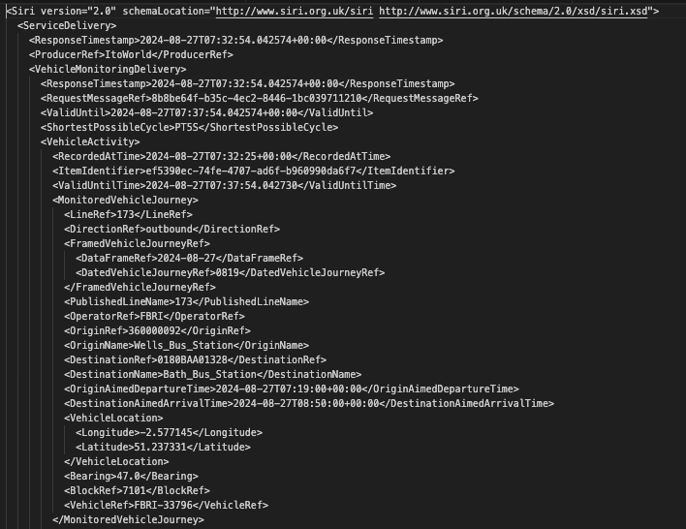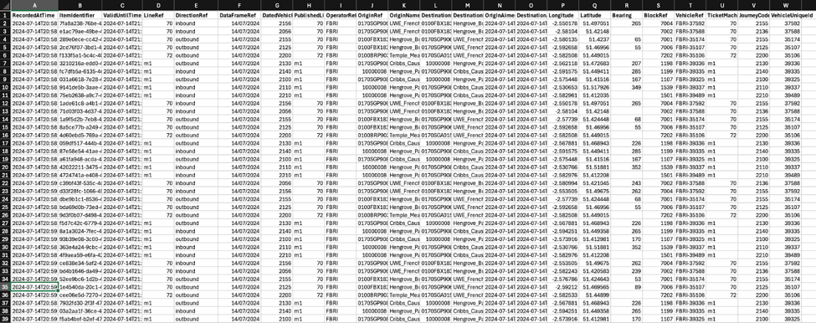

Figure 1. XML SIRI package and the captured CSV file.

To address the absence of unique trip identifiers within the SIRI data, a TripId field was generated by hashing a combination of line, vehicle identifier, dated journey code, direction, block number, and expected departure time. While core data such as timestamps, longitudes, latitudes, and bearing were collected, inconsistencies in bearing data led to its exclusion, necessitating the use of alternative methods, such as map-matching, to determine direction.

Moreover, instances of buses continuing to emit location signals post-trip completion resulted in a 30-50% increase in data volume. To mitigate this, only data corresponding to active trips—defined as those within planned departure and arrival times—were retained.

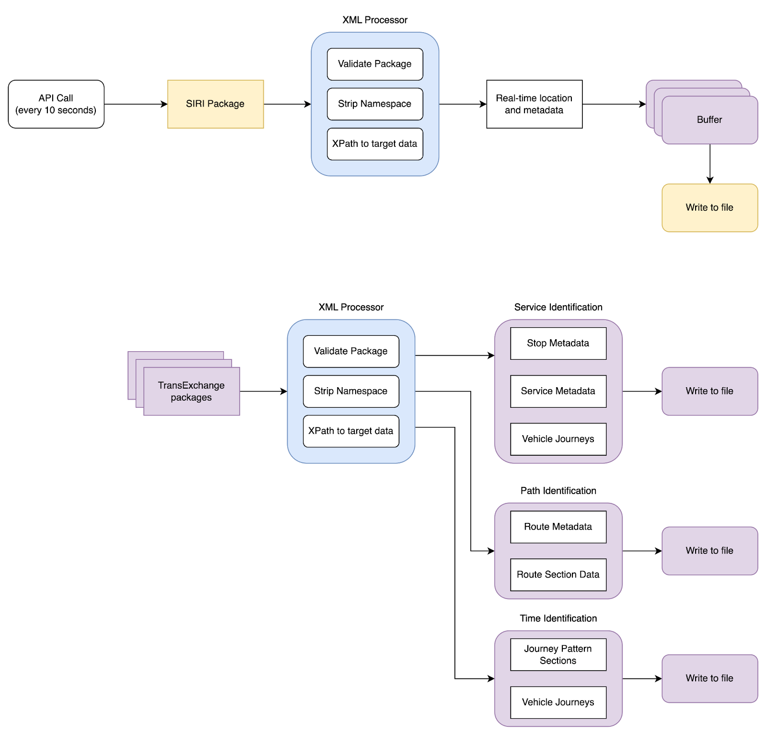A diagram illustrating the location data collection workflow is presented in Figure 2. The buffered data is written into archival CSV files daily (Figure 1b).

Figure 2. Data collection process for location data (SIRI packages).

### Timetable Data - TxC Packages

The timetable data, provided in the TxC-PTI standard [18, 20], offers comprehensive scheduling flexibility to operators, though its complexity posed technical challenges, with its documentation being ten times longer than that of the GTFS format [19, 20]. The data is organized into three primary categories: Service Identification, Path Identification, and Time Identification. Each of these categories was extracted and validated separately (Figure 3), ensuring consistency and accuracy in the subsequent mapping processes.

* Service Identification includes all possible stops on each line, service information, and vehicle journey codes.
* Path Identification provides end-to-end service route information and route sections in the form of geographical line strings.
* Time Identification includes journey pattern sections, which rearrange route sections into a complete route, and vehicle journeys, which contain expected timing information for each route section.

Given the complexities of the TxC format and its dependence on each operator's submission structure, the timetable data was manually selected within the study’s timeframe to avoid unnecessary complications. The validation process is a simplified version of the full process, detailed in Appendix A, due to all the data having the same format deployed by First Bus.



Figure 3. Data collection process for timetable data (TxC packages).

### Mapping the SIRI and TXC Data

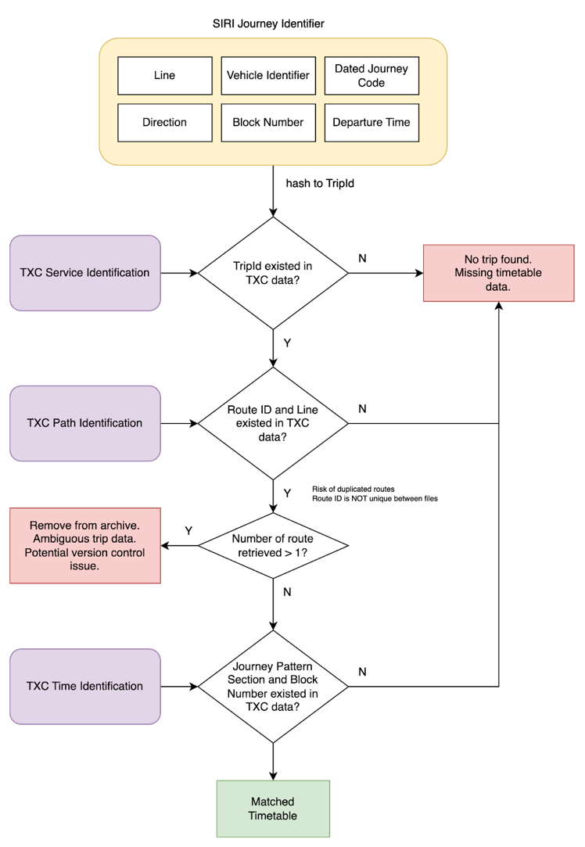Focusing on a single operator offers the advantage of data consistency, which simplifies the validation process as shown in Figure 4. However, there are instances where trips could not be mapped to their respective planned journeys due to the absence of archival timetables and complex version control leading to ambiguous mapping.

Figure 4. Mapping process between location and timetable data.

## Route Reconstruction and Analysis Techniques

Reconstructing bus trips from discrete time series is crucial for further analysis, particularly regarding speed at specific points. However, GPS signals are known to contain noise in urban environments, often resulting in recorded points that fall outside of the actual street, abruptly change directions, or occasionally return invalid values. The following methods were employed to address these challenges.

### Map-Matching Raw GPS Data

A map-matching process was implemented using the open-source mapping engine Valhalla [22], in conjunction with OpenStreetMap [23] data for the West of England [24, 25]. This approach projected raw GPS points onto road segments, algorithmically connecting them to form a continuous route. This method was essential for correcting noisy data and improving the accuracy of the route reconstructions.

An example of the map-matching results is shown in Figure 5, where red points represent noisy raw data, and white points represent the map-matched equivalents.

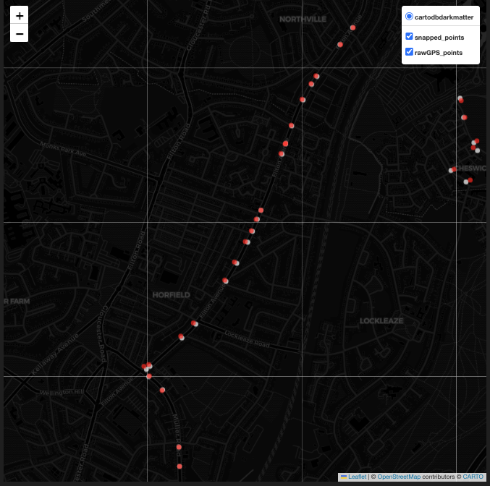

Figure 5. An example of map-matching. The red points are the raw GPS signals, and the white points are the map-matched equivalents.

### Signal Cluttering Issue

A common issue encountered was signal cluttering, where GPS points concentrated in small areas due to slow-moving buses, resulting in erratic "jumps" to nearby locations (Figure 6a and 6c). An algorithm was developed to declutter these points (Figure 7), with a detection radius set to 50 meters, which was the maximum observed GPS error. In extreme cases, where decluttering alone was insufficient, alternative methods were explored.

The results can be seen in Figures 6b and 6d, where white points represent decluttered raw data and the green line represents the estimated route, free of error.

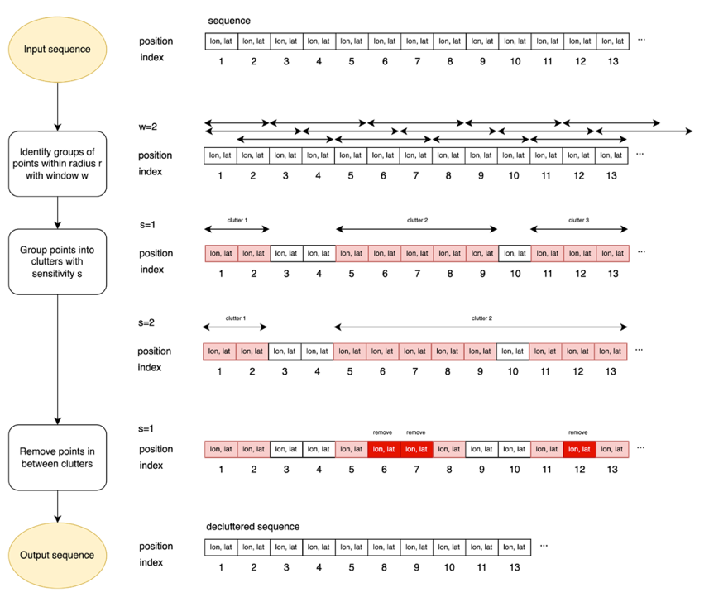

Figure 7. The algorithm used for decluttering the time series.

Figure 6. A demonstration for cluttering issue.

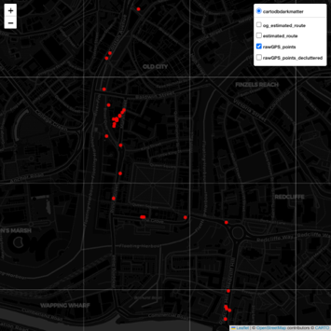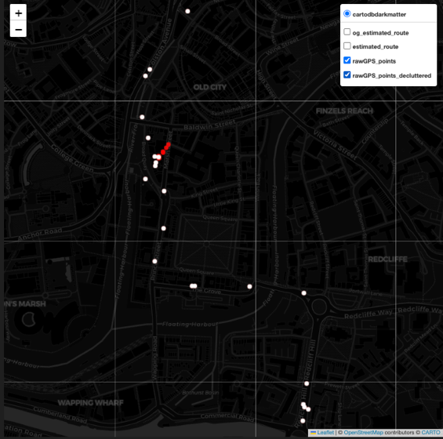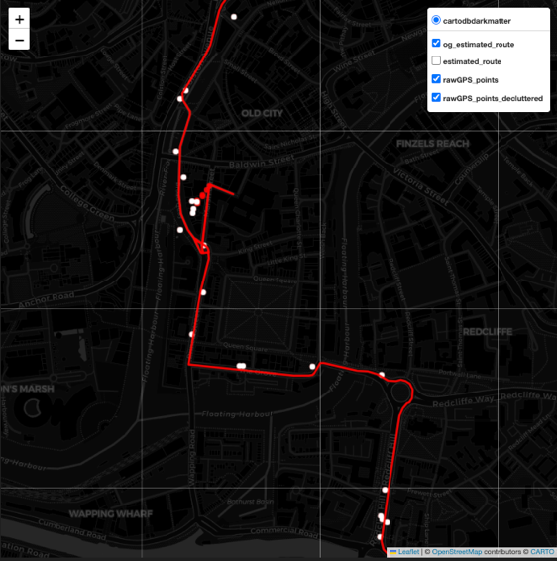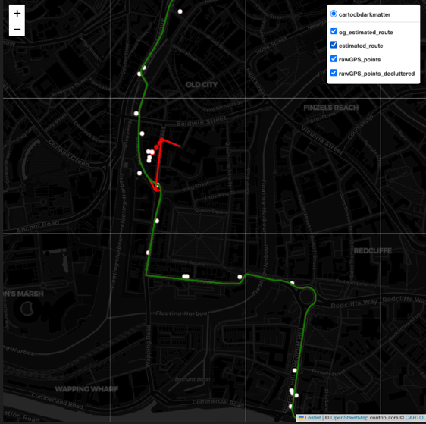

TripID: fdff693a-8e32-f394-c965-b5260ecaed45

Line 70, 0900, inbound, 2024-07-29, Block 7003, Vehicle 37607

a

b

c

d

### Time-Distance Analysis

With the location and time data mapped, a comparative analysis was conducted using a time-distance diagram (Figure 8b), a robust method for segment-by-segment analysis of parameters such as average speed and time deviation. Unlike geographically analysis conducted on maps (Figure 8a), this method also provides insights regarding temporal and spatial data at once.

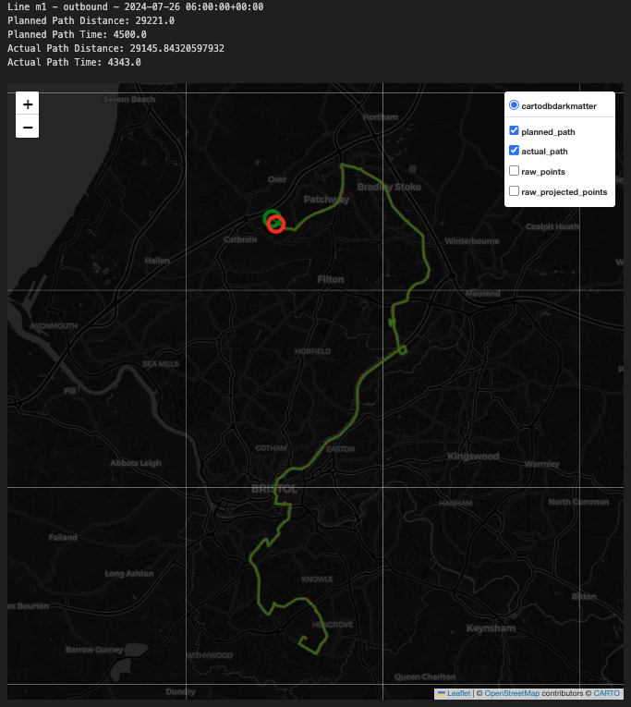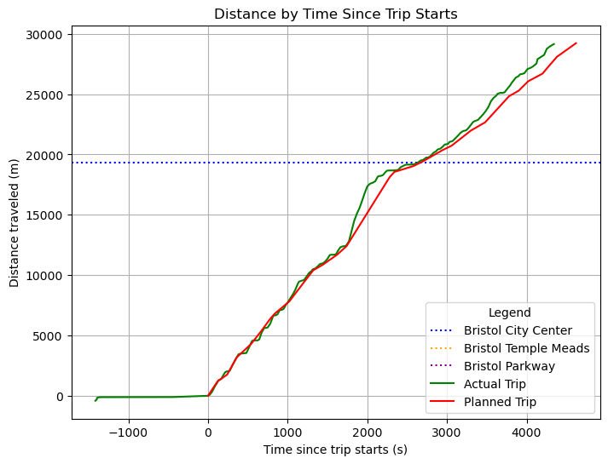

a

b

Figure 8. A demonstration on geographical and time-distance diagram, two ways of analysing bus data.

The time-distance diagram method assumes monotonic functions for time and distance travelled and uses linear interpolation [27] for trip-wise analysis, providing detailed insights into bus performance against planned schedules. To ensure the accuracy of the model, a trip adjustment process was employed and detailed in Appendix B.

## Performance Metric Definitions

Based on the map-matched results, various insights can be extracted from the data, focusing on three main categories:

* Trip general information and classification
* Trip geographical consistency
* Trip timing consistency
* Trip punctuation regarding specific stations

### Trip General Information

This category provides the overall trip performance, including:

* Planned Time and Planned Distance versus Actual Time and Actual Distance.
* Trip Types: Trips are classified into five categories based on observations in the adjustment process detailed in Appendix B.
  + Starts Recording Early: The bus starts sending signals earlier than the departure time.
  + Starts Recording Late: The bus starts sending signals after the departure time, or the recording process begins after the bus has already been deployed.
  + In Unfinished Previous Trip: The bus is still on previous trips, despite the planned departure time having passed.
  + Unplanned: The bus actively operates outside of its designated timeframe.
  + Other: All other cases.

### Trip Geographical Consistency

This category assesses how closely each trip matches its planned route:

* Matched Percentage: A segment is considered matched if the actual recorded data are within 10m of the planned route.
* Median GPS Error: From the map-matched reconstructed route, GPS error is determined by examining the differences between the raw and reconstructed points.
* Diversion Metrics: Referencing the reconstructed route against the planned trip reveals vital information on diversions taken by the bus. A diversion is defined as a route segment that deviates from the planned route by over 450m, which is the median distance between stops, which means it affects at least one stop.
  + Diversion Count: The number of diversions taken by the bus versus its planned route.
  + Diverted Path, Start Point, End Point: Detailed on the diverted segments.

Trip Timing Consistency

This category evaluates the timing performance against the planned trip:

* Time Deviation Statistics: Using interpolated data, time deviation is calculated for each trip. Statistics such as mean, median, standard deviation, and particularly deviation per km are extracted for insightful analysis.
* Punctuation Percentage: By examining time deviation at each segment, punctuation metrics can be constructed, where being on time is defined as being between 1 minute early and 5 minutes late [29].
* Trip Trend Types: Time deviation series analysis allows for classification of bus behaviour throughout the trip. The classification for trends includes:
  + Consistently On-Time: The bus consistently operates within the time deviation’s standard deviation (σ).
  + Slowing Down: The bus’s lateness increases through time.
  + Speeding Up: The bus’s lateness decreases through time.
  + Mid-Trip Delay: The bus experiences a significant delay in the middle section of the trip.
  + Mid-Trip Recovery: The bus significantly increases speed from the middle section of the trip.
  + Complex Trend: The bus exhibits erratic time deviation patterns (CV > 1) or other behaviours.

### Trip Punctuation for Key Stations

This project also examines the punctuation concerning the movement of buses connecting UWE and key Bristol connecting stations. Table 1 details the key stations and their respective bus lines departing from UWE Bristol.

Table 1. Key stations for transportation hub and the corresponding bus lines status, departing from UWE Bristol.

|  |  |  |  |  |  |  |
| --- | --- | --- | --- | --- | --- | --- |
| **Station Name** | **70** | **74** | **72** | **m1** | **m3** | **m4** |
| *Bristol Temple Meads* | No | **Yesi** | **Yesi** | No | No | No |
| *Bristol Parkway* | No | No | No | No | No | **Yeso** |
| *Broad Quay (City Centre)* | **Yesi** | **Yesi** | **Yesi** | **Yeso** | **Yesi** | **Yesi** |

i: inbound trips; o: outbound trips

## Ethical Considerations

This study employed high-resolution GPS data from the BODS system to assess bus service reliability in Bristol. Although the data was in public domain, anonymised and free from personal identifiers, several ethical measures were implemented to ensure compliance with ethical standards.

Firstly, the data used was public transport data, devoid of any personally identifiable information. Although the data used is on vehicle level, to further safeguard privacy, data was handled in a way that minimised the risk of indirect identification or inference of sensitive information.

Secondly, the study considered the broader impact of its findings, aiming to enhance bus services for international students. The conclusions were presented constructively, avoiding unjust criticism of specific routes or operators.

The right to use this data is protected with the Open Government Licence v3.0. However, the research was conducted with a commitment to respecting the rights and privacy of individuals. Throughout the research, transparency was upheld. Methodologies were clearly documented, and limitations, including potential data inaccuracies, were acknowledged to allow for critical evaluation.

# Analysis and Result

## Preliminary Raw Data Quality Analysis

Ensuring the quality of collected data is a crucial preliminary step in any research project, particularly when the findings will inform critical operational decisions. For this project, a preliminary analysis of the raw data was conducted to identify potential quality issues that could affect the reliability of subsequent analyses.

Figure 9. Raw data record distribution and classification for cleaning.

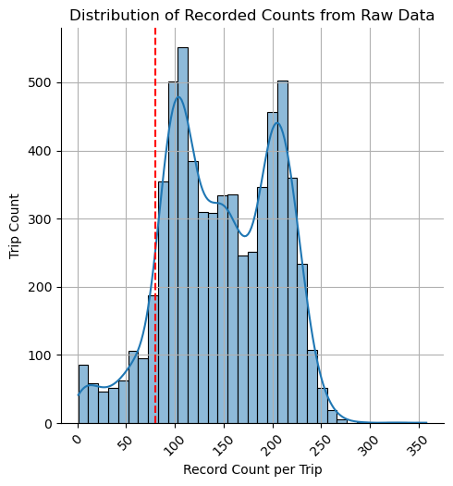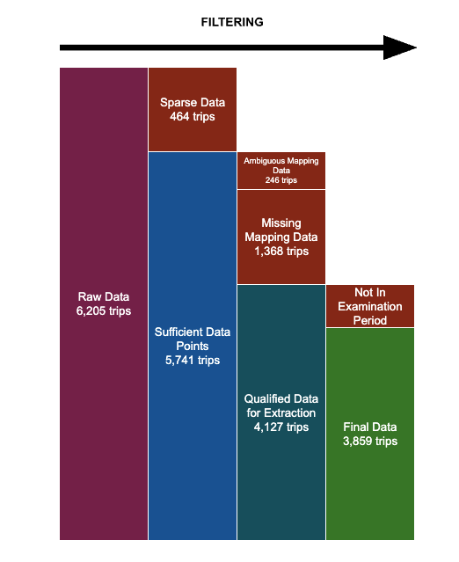

The first issue identified pertains to the sparseness of location data in a subset of the trips. Approximately 7.4% of the trips were found to have very sparse location points, defined as being in the lowest 10% percentile of the record-per-trip distribution (illustrated by the red vertical line in Figure 9a). Sparse data significantly limits the amount of information that can be extracted, even with map-matching process employed. Such sparseness could potentially lead to inaccurate tracking and unreliable performance metrics, requiring careful consideration in the subsequent analysis phases.

A more significant issue identified was the absence of timetable references for 22% of the data, corresponding to 1,368 trips. This missing data is primarily attributed to the absence of Block Numbers, which are essential for linking trips to their respective timetable references. Block Numbers serve as unique identifiers for the series of journeys a particular bus might take throughout the day. The missing Block Numbers are likely due to the unavailability of archival timetable data, as the relevant identifiers were not carried over from previous revisions of the timetable.

A detailed examination revealed that the majority of the missing timetable data occurred in the m1, m3, and m4 bus lines. The m1 line was particularly affected, with 714 trips missing from the timetable references, likely due to the large fleet size and the frequency of deployments. The m3 and m4 lines also exhibited significant data loss, losing 290 and 360 trips respectively. In contrast, the 70 and 72 lines had negligible data loss, each with only 0.15% of trips missing.

Table 2. Data loss due to missing timetable data reference.

|  |  |  |
| --- | --- | --- |
| **Line** | **Missing Trip Count** | **Percentage** |
| 70 | 2 | 0.15% |
| 72 | 2 | 0.15% |
| m1 | 714 | 52.19% |
| m3 | 290 | 21.20% |
| m4 | 360 | 26.32% |

Due to current limitations with the BODS system, it was not possible to retrieve the missing data, which poses a challenge for the completeness of the dataset. The significant amount of missing data, particularly in the m1 line, could potentially bias the analysis if not accounted for appropriately.

Minor data issues were also identified, including ambiguous mapping data (less than 4%) and the presence of data outside the project’s defined time scope (less than 5%). Ambiguous mapping data refers to instances where a single trip could be matched to two or more possible planned routes, creating uncertainty in the analysis. However, this issue can be addressed by applying the full data validation process currently employed by the Department for Transport (DfT) and its partners, ensuring that only the most accurate route is selected for each trip.

After addressing the identified issues, the final dataset ready for analysis comprised 3,859 trips, representing approximately 62% of the original raw data. While this reduction in data volume reflects the necessary exclusion of unreliable records, it also underscores the importance of robust data validation processes to ensure the integrity of the analysis.

## Overall Line Performance

This section presents a comprehensive analysis of bus line performance based on aggregated metrics and directional insights, particularly focusing on departures from UWE. The analysis evaluates key performances indicators such as time deviation, GPS accuracy, punctuality, and diversion rates. Additionally, the performance at critical locations is examined to provide an in-depth understanding of each line’s operational efficiency. The detailed information can be referenced from Table 3 and Table 4.

Line 70 demonstrates strong adherence to its schedule, with an overall average time deviation of only 22 seconds. The GPS tracking accuracy is reliable, with a median error of 5.3 meters. Although 21% of trips experienced diversions, only 3.7% involved significant route changes. The line maintains a high on-time rate (59.6%) and exhibits a minor deviation per kilometre. Both inbound (UWE to City Centre) and outbound trips show consistency, with only slight variations in performance, indicating a well-balanced operation.

Line 72, however, struggles with significant delays, particularly on inbound trips. Overall, the mean time deviation is 203 seconds, with a high late percentage (35%). Inbound trips, heading to Bristol Temple Meads from UWE, are notably problematic, with a mean deviation of 345.4 seconds, primarily due to buses starting slowly and attempting to catch up later in the route. Outbound trips perform better, with a mean deviation of 69.2 seconds and higher punctuality (71.9%). Despite these challenges, the line maintains a high route matching percentage (96%) and a low rate of impactful diversions (1.3%). However, substantial delays up to 7 or 8 minutes are observed at Bristol Temple Meads and City Centre on inbound routes.

Line 74 exhibits a balanced performance with a moderate average time deviation of 67 seconds and the highest on-time segment percentage (66.3%) among the lines studied. The line shows strong route stability, with only 8.7% of trips experiencing diversions, and just 1.9% of these involving significant changes. Inbound trips (UWE to City Centre and Temple Meads) experience slightly more delays at key stops, but the overall on-time performance remains high. The average time deviation per kilometre is minimal, making this line one of the most reliable in the study.

Line m1 performs well, particularly on outbound trips from UWE to the City Centre, where it exhibits a minor average deviation of just 15 seconds at Bristol City Centre. However, the line faces significant challenges with diversions, especially outbound, where 36% of trips are affected, and 14% impacting more than three bus stops. Inbound trips maintain a decent on-time performance (70.6%), but the overall reliability is hindered by the high diversion rate and a lower route matching percentage (92%).

Line m3 is characterised by a strong tendency for early arrivals, particularly on outbound trips, with an average time deviation of -470.5 seconds. Inbound trips, heading to City Centre from UWE, are more balanced, with a mean deviation of -54.5 seconds, but still tend to arrive early. The line has a moderate diversion rate (18.15%), but the early arrival pattern is consistent, especially at Bristol City Centre, where buses arrive significantly ahead of schedule.

Line m4 shows a significant contrast between inbound and outbound performance. Inbound trips from UWE to the City Centre exhibit moderate early arrivals, with a mean deviation of -24.6 seconds. In contrast, outbound trips to Bristol Parkway are heavily skewed towards early arrivals, with a mean deviation of -363 seconds, and 80% of segments arriving earlier than scheduled. This pattern, while potentially advantageous for commuters, poses challenges for maintaining a consistent service level.

Table 3. Aggregated metrics by bus line.

|  |  |  |  |  |  |  |  |  |  |  |  |  |
| --- | --- | --- | --- | --- | --- | --- | --- | --- | --- | --- | --- | --- |
| **Line** | **Mean Deviation (seconds)** | **Median GPS Error (m)** | **Diversion Percentage (%)** | **Diverted More Than 3 Stops (%)** | **Segment-wise Ontime (%)** | **Segment-wise Late (%)** | **Segment-wise Early (%)** | **Matched Percentage (%)** | **Deviation Per Km (s/km)** | **Bristol Temple Meads Time Deviation (seconds)** | **Bristol Parkway Time Deviation (seconds)** | **Bristol City Centre Time Deviation (seconds)** |
| 70 | 22.4 | 5.3 | 21.3 | 3.7 | 59.64% | 18.03% | 22.33% | 95.68% | 0.0 |  |  | -71.8 |
| 72 | 203.8 | 4.9 | 20.2 | 1.3 | 55.09% | 34.59% | 10.32% | 95.69% | 35.0 | 267.9 |  | 273.5 |
| 74 | 67.3 | 5.3 | 8.7 | 1.9 | 66.33% | 12.07% | 21.59% | 97.41% | 10.3 | 74.9 |  | 56.6 |
| m1 | 72.2 | 5.7 | 32.6 | 14.2 | 68.83% | 12.28% | 18.89% | 91.96% | 11.9 |  |  | 53.7 |
| m3 | -225.4 | 6.8 | 18.2 | 2.9 | 40.38% | 0.23% | 59.39% | 96.02% | -44.4 |  |  | -169.6 |
| m4 | -187.5 | 5.3 | 22.6 | 2.5 | 42.68% | 1.80% | 55.52% | 95.77% | -36.6 |  | -157.0 | -108.3 |

Table 4. Aggregated metrics by bus line and direction of travel.

|  |  |  |  |  |  |  |  |  |  |  |  |  |  |
| --- | --- | --- | --- | --- | --- | --- | --- | --- | --- | --- | --- | --- | --- |
| **Line** | **Direction** | **Mean Deviation (seconds)** | **Median GPS Error (m)** | **Diversion Percentage (%)** | **Diverted More Than 3 Stops (%)** | **Segment-wise Ontime (%)** | **Segment-wise Late (%)** | **Segment-wise Early (%)** | **Matched Percentage (%)** | **Deviation Per Km (s/km)** | **Bristol Temple Meads Time Deviation (seconds)** | **Bristol Parkway Time Deviation (seconds)** | **Bristol City Centre Time Deviation (seconds)** |
| 70 | ***inbound*** | 19.68 | 4.98 | 27.16 | 3.85 | 64.51% | 23.26% | 12.23% | 95.24% | -0.87 |  |  | ***-62.87*** |
| 70 | outbound | 25.16 | 5.65 | 15.62 | 3.59 | 54.89% | 12.91% | 32.20% | 96.10% | 0.91 |  |  | -80.56 |
| 72 | ***inbound*** | 345.41 | 4.41 | 21.55 | 2.59 | 37.37% | 61.95% | 0.68% | 95.68% | 59.52 | ***462.95*** |  | ***440.64*** |
| 72 | outbound | 69.17 | 5.10 | 18.85 | 0.00 | 71.94% | 8.57% | 19.49% | 95.70% | 11.66 | 82.36 |  | 114.55 |
| 74 | ***inbound*** | 106.38 | 5.03 | 8.05 | 1.44 | 68.84% | 15.38% | 15.77% | 97.62% | 18.40 | ***84.65*** |  | ***82.10*** |
| 74 | outbound | 28.96 | 5.69 | 9.32 | 2.26 | 63.86% | 8.82% | 27.32% | 97.20% | 2.37 | 65.30 |  | 31.50 |
| m1 | inbound | 58.00 | 5.68 | 29.17 | 14.39 | 70.62% | 10.59% | 18.79% | 91.83% | 9.44 |  |  | 91.92 |
| m1 | ***outbound*** | 86.30 | 5.65 | 35.98 | 14.02 | 67.04% | 13.98% | 18.98% | 92.09% | 14.40 |  |  | ***15.38*** |
| m3 | ***inbound*** | -54.50 | 5.89 | 14.05 | 3.78 | 62.97% | 0.40% | 36.64% | 96.28% | -11.01 |  |  | **-187.36** |
| m3 | outbound | -470.45 | 7.66 | 24.03 | 1.55 | 7.99% | 0.00% | 92.01% | 95.65% | -92.17 |  |  | -144.16 |
| m4 | ***inbound*** | -24.63 | 5.07 | 15.52 | 2.16 | 65.20% | 2.58% | 32.22% | 96.41% | -5.07 |  | -1.90 | ***-91.70*** |
| m4 | ***outbound*** | -363.31 | 5.46 | 30.23 | 2.79 | 18.39% | 0.95% | 80.67% | 95.09% | -70.61 |  | ***-324.28*** | -126.24 |

## Case Study: Route Adherence Analysis for Line m1

### Overview

This case study focuses on the route adherence issues observed in Line m1, a line identified previously for its significant diversion problems. The analysis revealed that Line m1 suffers from substantial deviations from its pre-planned routes, with approximately 30% of trips experiencing diversions, of which 14% may result in serious operational impacts. The following sections examine the specific patterns of these diversions, examining both minor and more severe cases.

Figure 10. Matched percentage statistics of all lines and of line m1.

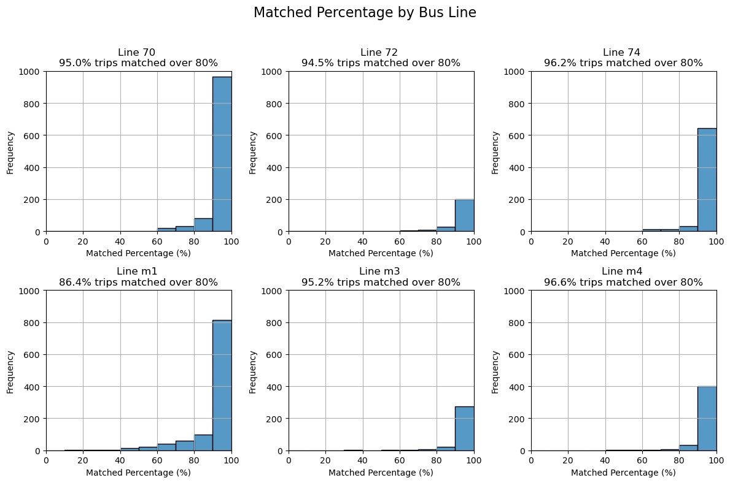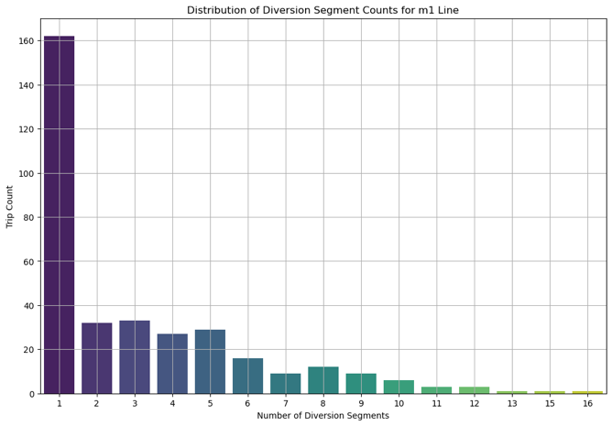

a

b

### Diversion Frequency and Severity

Histograms in Figure 10a highlight that Line m1 has the highest rate of route mismatches among the analysed lines. Most diversions involve just one segment (Figure 10b), but 2 to 6 segment diversions are also common, dropping sharply beyond six segments. Swarm plots reveal that while most diversions are reasonable in length, outliers exist where the diversion length is nearly as long as the entire trip, suggesting signal issues or significant route deviations. However, these extreme cases are rare.

Figure 11. Swarm plot for diverted trips by average diversion length and by hour of day.

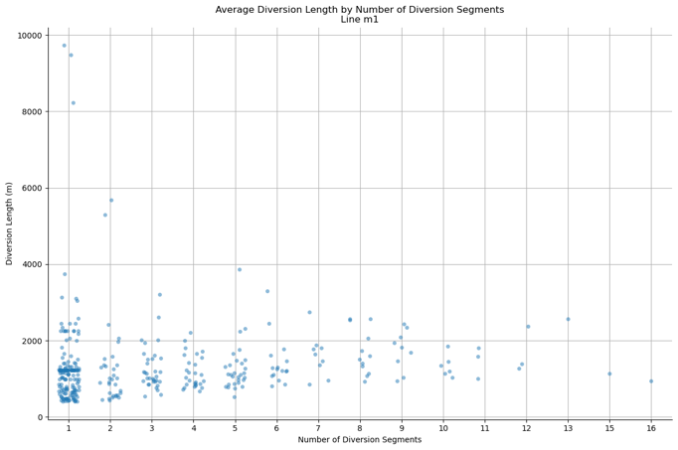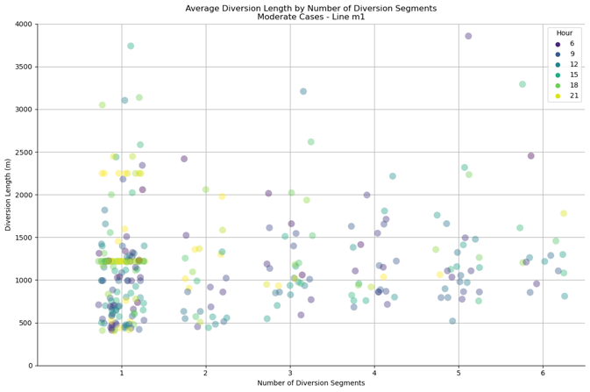

a

b

### One-Segment Diversions

Analysis of one-segment diversions using swarm plot (Figure 11b) by the hour of day reveals distinct patterns. Diversion lengths at 1,000 meters, 1,250 meters, and 2,250 meters cluster around specific times - 6-9 AM, 3-6 PM, and 6-9 PM - indicating systematic, temporary route changes rather than random occurrences. For example, on July 25th and 26th, 2024, buses consistently diverted onto Coronation Road instead of Bedminster Parade (Figure 12a). Similarly, evening trips from July 29th to 31st showed consistent diversions at Patchway (Figure 12b). These patterns suggest that Line m1 frequently implements planned diversions while maintaining high on-time performance.

Figure 12. Systematic route changes observed in line m1.

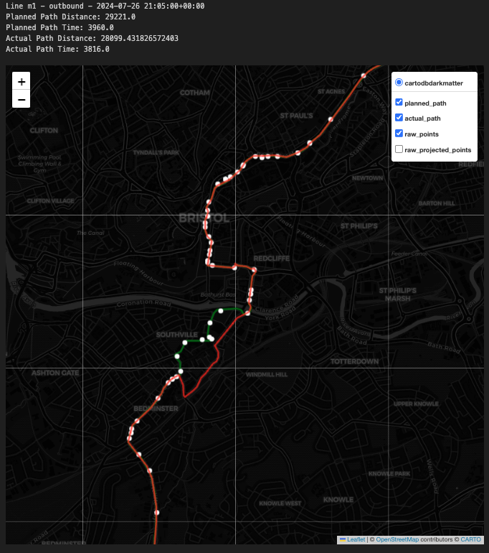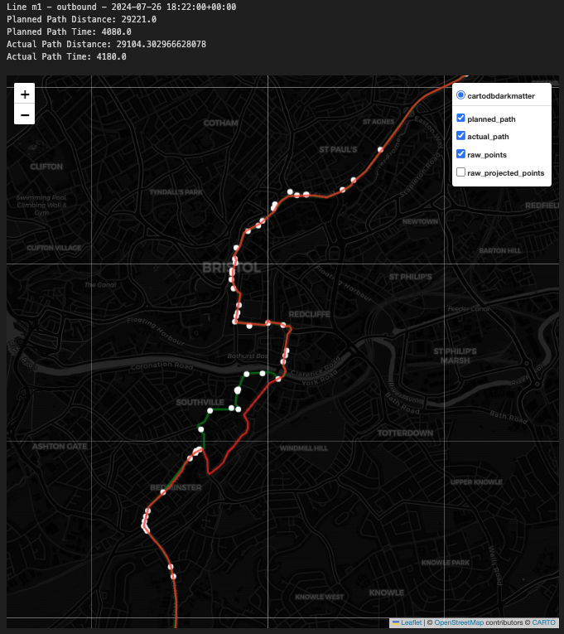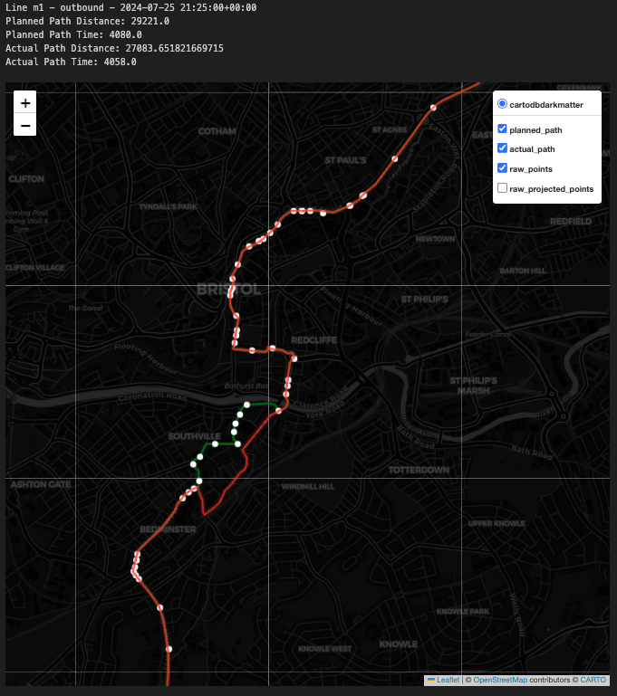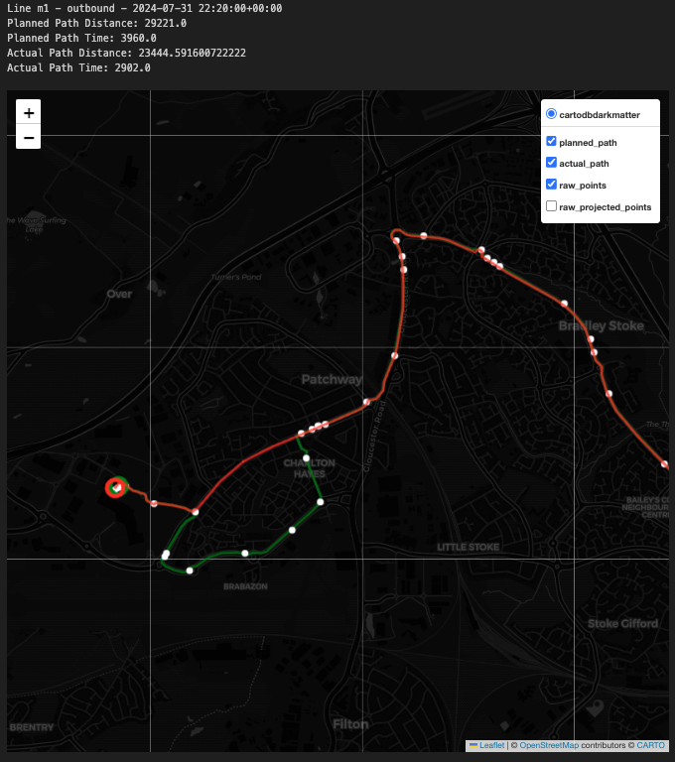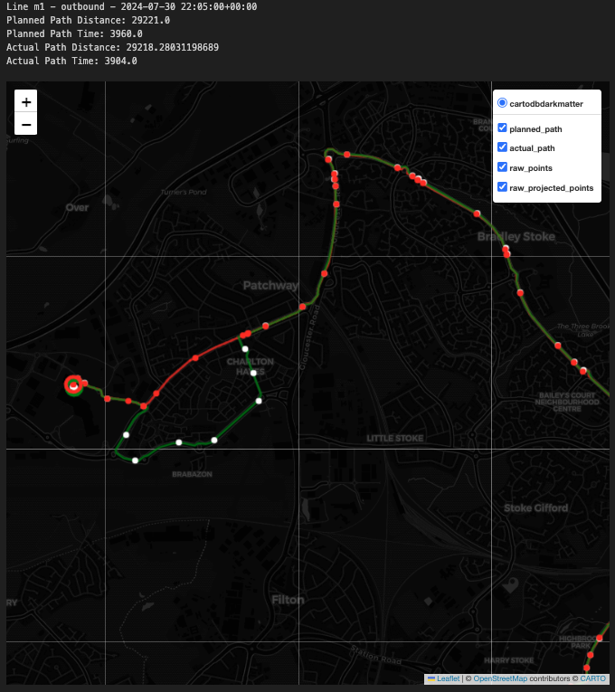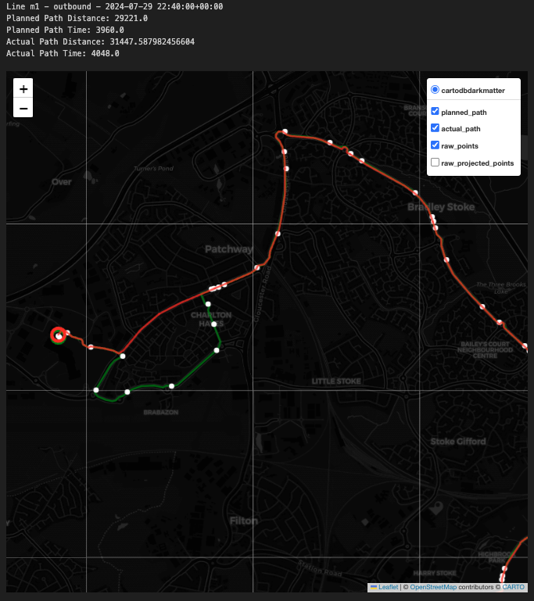

a

b

### Moderate and Extreme Diversion Cases

In moderate cases (2 to 6 segments), no clear patterns emerged, indicating that GPS signal noise is likely the cause. Figure 13a shows high GPS data dispersion, leading to inaccurate map-matching, particularly in dense road networks. Some genuine diversions were observed (Figure 13b), but many were distorted by GPS noise. Extreme cases, with more than six segments, are rare and appear randomly, largely due to severe GPS inaccuracies (Figure 13c). Two specific buses (FBRI-39336 and FBRI-39321) were identified as the main culprits, suggesting equipment issues.

Figure 13. GPS error patterns and top unique vehicles with severe route diversions.

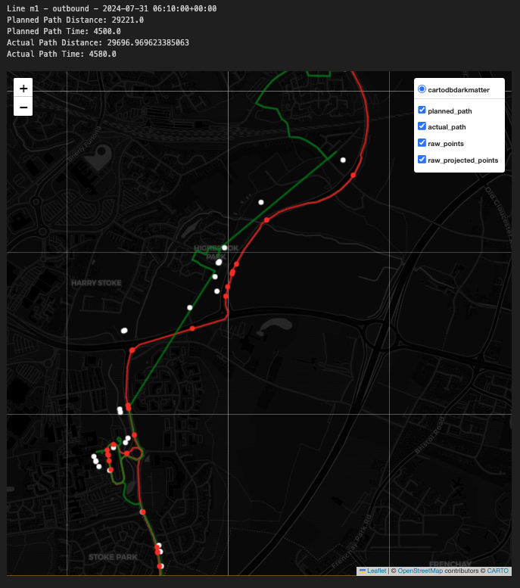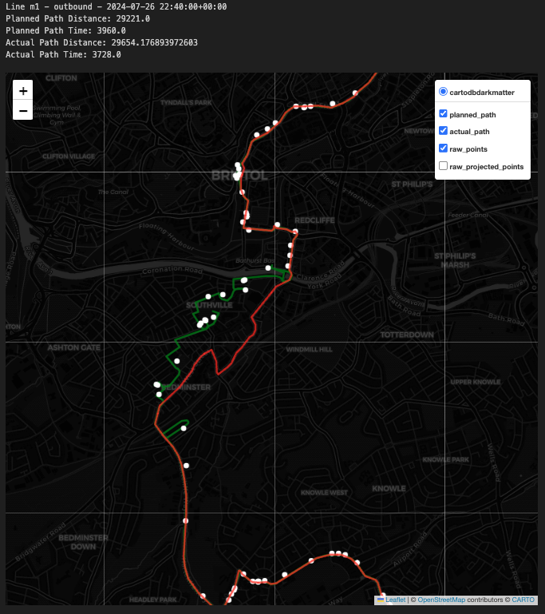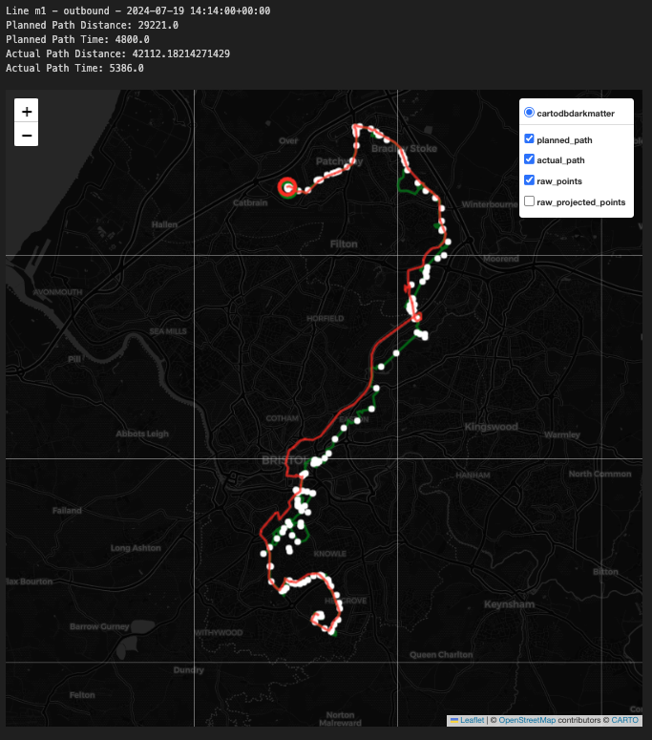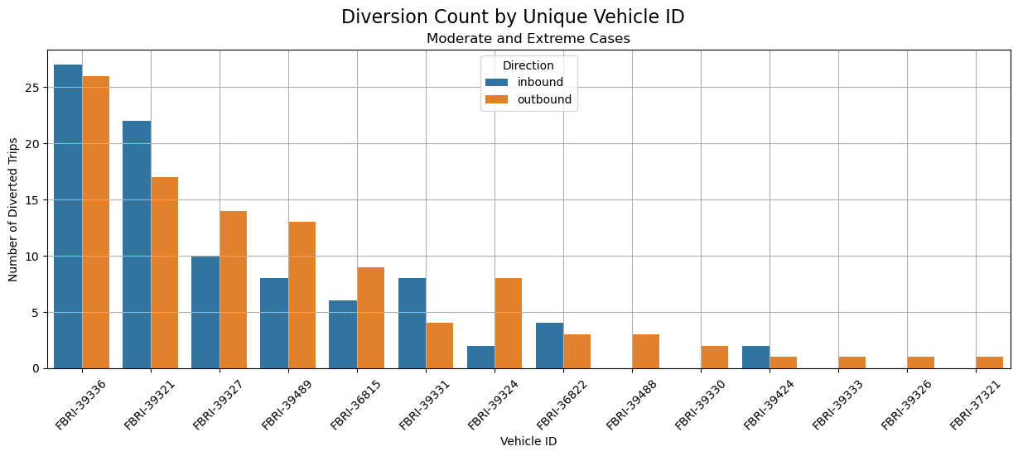

a

b

c

d

## Case Study: Time Consistency Analysis for Line 72, m3 and m4

### Overview

This case study investigates the significant time deviations observed on lines 72, m3, and m4, particularly focusing on their departures from the UWE stop. Previous analyses highlighted line 72’s frequent delays, while Lines m3 and m4 exhibited tendencies for early arrivals. This analysis aims to uncover the underlying causes of these patterns and assess their implications for passengers.

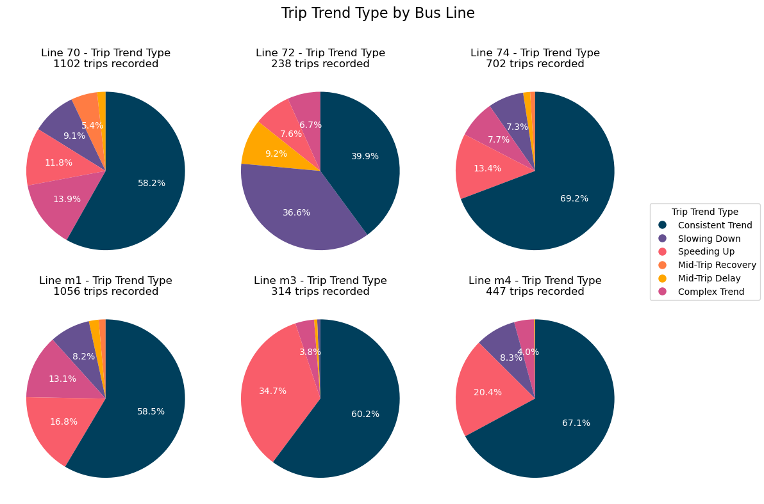The time difference by distance travelled plots in Figures XXX, YYY and ZZZ illustrate the distribution of time deviations at key Bristol locations (Temple Meads, Parkway, and City Centre) for line 72, line m3 and line m4. Notably, line 72 exhibits a wider spread of time deviations, particularly at Temple Meads and City Centre, indicating buses frequently arrive significantly later than scheduled. Line m3 and line m4, however, demonstrate a distinct pattern of early arrivals where buses often arrive much earlier than planned.

Figure 14. Trip trend types by bus lines.

### Line 72 - Inbound

Line 72, especially on inbound routes from UWE to Bristol Temple Meads, suffers from substantial delays. The trip trend analysis reveals that 36% of these trips are characterised by a "Slowing Down" trend, making it the least consistent line in terms of time adherence. Time difference plots indicate that buses frequently depart UWE late, with delays accumulating by the route’s passage through residential areas between Hogarth Walk and Nevil Road. These areas are prone to congestion due to narrow roads and numerous stops, causing further time loss. Although there are signs of buses attempting to recover time after Nevil Road, the heavy traffic in Bristol City Centre limits their ability to regain lost time. As a result, delays of 4.5 to 12 minutes are common by the time the buses reach City Centre or Temple Meads, indicating significant punctuality challenges for this line.

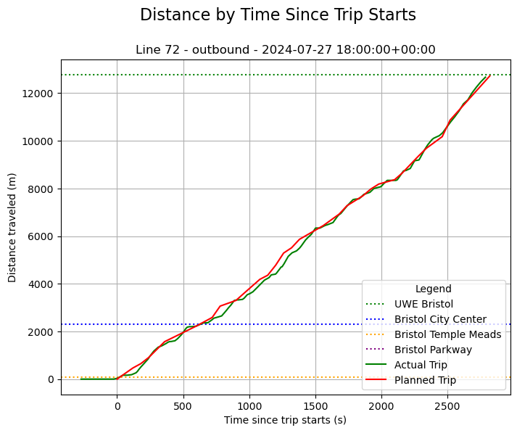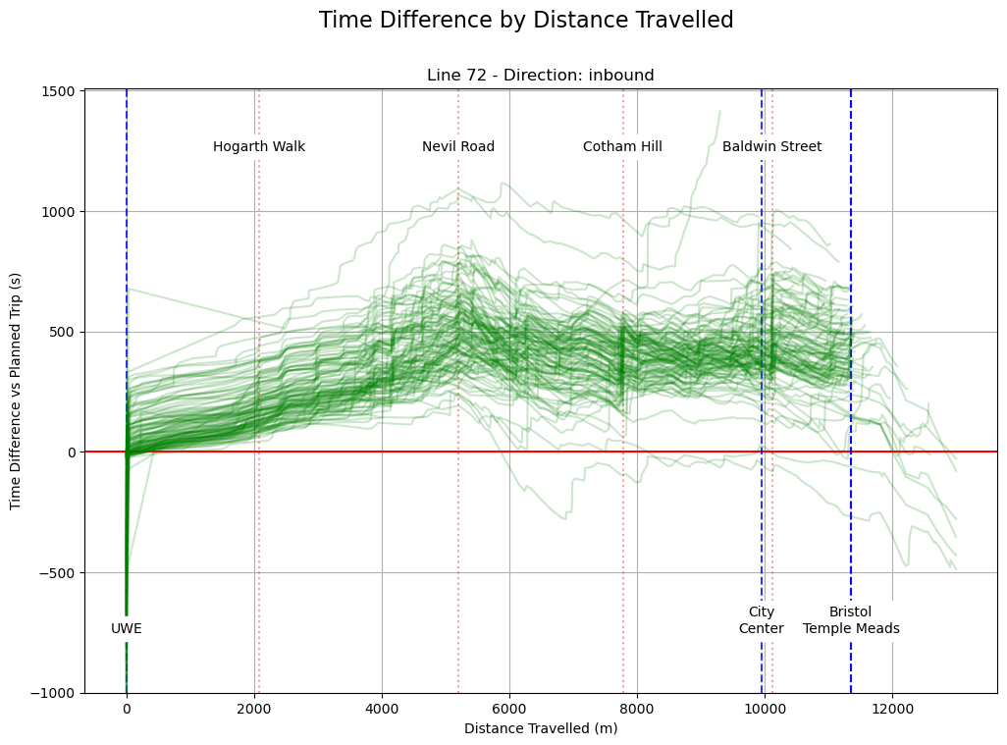

Figure 15. A distance by time diagram of a typical 72 bus (left) and time difference by distance graph for all the 72 outbound trips observed (right).

### Line m3 - Inbound

Line m3 inbound trips, from UWE to Bristol City Centre, shows a contrasting pattern, with a consistent trend of early arrivals. Despite a relatively high on-time percentage, a considerable number of trips exhibit a "Speeding Up" trend. The analysis indicates that buses on Line m3 often start on time and maintain this pace until they reach the Willy Wicket station. From this point, the buses tend to speed up, arriving at subsequent stops well ahead of schedule. This pattern suggests that the route’s design, which largely follows major roads with high capacity and dedicated bus lanes, facilitates faster travel. However, this also means that buses frequently must wait at stops to align with the scheduled time, potentially causing confusion for passengers - especially international students who plan their trips ahead of time - who might miss their bus if they arrive expecting the bus to be on time.

Figure 16. A distance by time diagram of a typical m3 bus (left) and time difference by distance graph for all the m3 inbound trips observed (right).

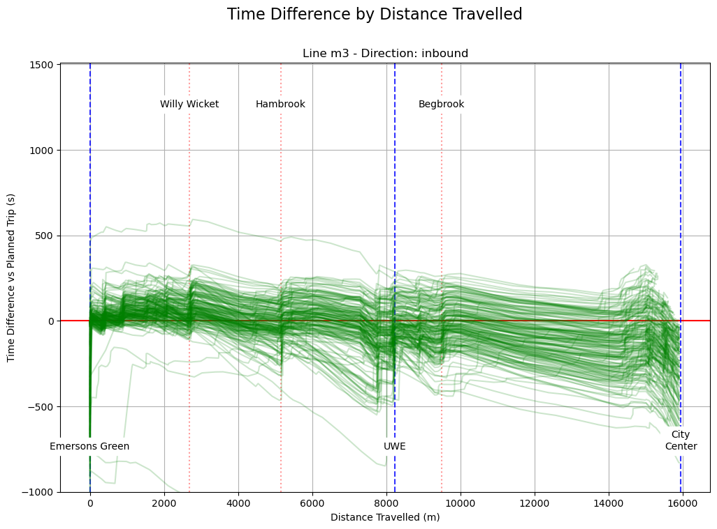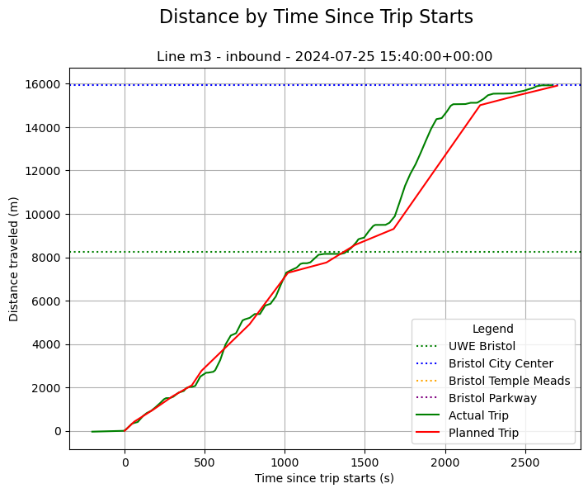

### Line m4 - Outbound

Line m4, particularly on outbound trips from UWE to Bristol Parkway, mirrors the early arrival trend observed in Line m3 but to a lesser extent. Buses on Line m4 tend to start on time and quickly move ahead of schedule due to favourable road conditions. However, unlike Line m3, these buses exhibit minimal waiting time at stops, leading to less pronounced early arrivals. The analysis suggests that buses on Line m4 often spend minimal time waiting at Bristol Parkway, likely to passenger drop-offs only, which contributes to the faster overall travel time. Further examination of inbound trips confirms this, as it shows that the inbound trips from Bristol Parkway to City Centre stops significantly more frequently, suggesting the inbound trips to be more popular.

Figure 17. A distance by time diagram of a typical m4 bus (left) and time difference by distance graph for all the m4 outbound trips observed (right).

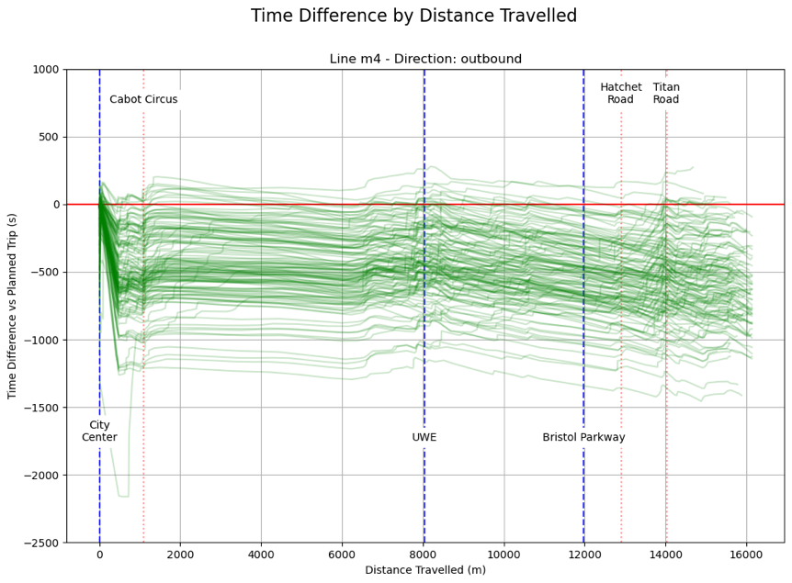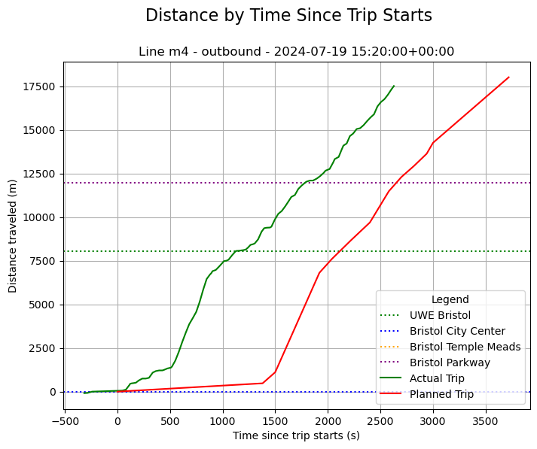

## Analysis and Case Study Summary

In summary, the analysis of the bus lines serving international students in Bristol revealed several critical insights into their performance. Line 70 demonstrated strong adherence to its schedule with minimal delays and high on-time performance, making it one of the most reliable routes studied. In contrast, line 72 faced significant challenges, particularly on inbound trips, where delays were frequent and substantial, especially around key locations like Bristol Temple Meads and the City Centre. Line 74 showed a balanced performance with moderate delays and a high percentage of on-time segments, indicating a generally reliable service.

Line m1 was identified as having considerable issues with route adherence, with a high percentage of trips experiencing diversions, some of which were severe enough to impact operational efficiency. Line m3, on the other hand, exhibited a tendency for early arrivals, particularly on outbound trips, which, while less disruptive than delays, could still pose challenges for passengers planning their journeys. Similarly, line m4 showed a pattern of early arrivals, especially on outbound trips, though to a lesser extent than line m3.

Overall, the analysis highlighted both the strengths and weaknesses of the bus services, with some lines showing consistent reliability and others struggling with punctuality and route adherence. These findings underscore the need for targeted improvements to enhance the overall reliability of bus services for international students in Bristol, ensuring they can depend on public transport for their daily needs.

**Discussion**

# Result Implications

The analysis of bus line performance offers crucial insights into the operational efficiency of Bristol’s public transport system, particularly concerning the needs of international students at UWE. The overall performance indicates that certain bus lines, such as line 70 and line 74, are reliable and consistent in their adherence to schedules, making them ideal choices for students who rely heavily on public transport. In contrast, line 72’s frequent delays, especially on inbound routes, highlight the potential for missed connections and the importance of planning for alternatives. This discrepancy in performance across lines underscores the need for informed decision-making when selecting bus routes, particularly for those unfamiliar with the city's transport network.

For key stations, the results suggest that international students departing from UWE should primarily rely on line 74 when traveling to **Bristol Temple Meads Station**, due to its balanced performance and relatively low incidence of delays. However, should line 72 be the only available option, students are advised to plan with at least a 15-minute buffer to mitigate the risk of missing their connections. For trips to **Bristol City Centre**, line 70 emerges as the best performer, providing consistent and reliable service. However, lines m3 and m4 also offer viable alternatives, often arriving earlier than scheduled, which could be advantageous for students with tight schedules. Line m1, with its higher frequency, offers flexibility in planning and is also a strong contender for journeys to the city centre. Line m4 is recommended for students traveling to **Bristol Parkway Station**, as this line tends to arrive early on outbound trips, usually reaching the station ahead time.

These findings have practical implications for improving the travel experience of international students, who may face additional challenges due to unfamiliarity with the local transportation system. By highlighting the most reliable routes and suggesting strategies for managing less predictable lines, this study provides valuable guidance that can help international students navigate Bristol’s public transport more effectively.

# Practical Application

The findings of this study have significant practical applications for various stakeholders, including the Department for Transport, bus operators, and independent developers. For the Department for Transport and bus operators, the insights gained from this analysis could inform efforts to enhance the reliability of bus services, particularly on lines like 72, where delays are frequent. By understanding the specific challenges faced by international students, these stakeholders can develop targeted strategies to improve service punctuality and user experience, such as adjusting the route timings on constantly delayed trips or providing disruptions information faster to help users plan better.

For independent developers and students, this study highlights the potential to leverage the Bus Open Data Service (BODS) to create innovative solutions that enhance public transport reliability. Given that BODS is a relatively new system, with limited online resources and guidance available, there is a significant opportunity for developers to contribute to the body of knowledge by creating tools, apps, or research projects that utilise this data. By doing so, they can help pave the way for more sophisticated public transport solutions, ultimately benefiting not only international students but also the wider community.

# Research Limitations

There are limitations while conducting this project that need to be discussed. One of the primary challenges was the absence of historical data within the BODS system, which limited the ability to conduct long-term trend analysis. The relatively short timeframe of data collection may not capture seasonal variations, or the full spectrum of operational challenges faced by the bus lines. Additionally, the reliance on GPS data, which can be prone to inaccuracies in dense urban environments, could have affected the precision of the route reconstructions and time-distance analyses. The study also faced data loss due to missing timetable references, particularly on line m1, which may have introduced bias into the results.

Another limitation lies in the scope of the study, which focused on a specific set of bus lines and did not account for all possible routes international students might use. As such, the findings may not be fully generalizable to other routes or to the broader population of bus users in Bristol. Moreover, the study primarily concentrated on the operational aspects of the bus lines, with less emphasis on user satisfaction or the qualitative aspects of the passenger experience, which could offer additional valuable insights.

# Future Study

Future research could address these limitations by expanding the data collection period to include more extensive historical data, once available, to capture longer-term trends and seasonal variations. Additionally, incorporating qualitative research methods, such as surveys or interviews with international students, could provide a more comprehensive understanding of their experiences and needs. Further studies could also explore the integration of BODS data with other sources, such as traffic or weather data, to develop more sophisticated predictive models for bus performance. Expanding the scope to include a broader range of bus lines and exploring the potential for real-time disruption alerts could also enhance the practical utility of future research.

**Conclusion**

# Summary of Key Findings

This study has provided a comprehensive analysis of bus line performance in Bristol, focusing on the specific needs of international students. The key findings reveal significant variations in the reliability and punctuality of different bus lines. Line 70 emerged as the most reliable option for reaching Bristol City Centre, with minimal delays and high on-time performance. Line 74 also showed strong performance, making it the best choice for traveling to Bristol Temple Meads Station. However, line 72 demonstrated frequent delays, particularly on inbound routes, necessitating that students plan with additional time to ensure timely arrivals. The analysis of Lines m1, m3, and m4 highlighted a pattern of early arrivals in line m3 and m4, with line m1 also benefiting from a higher frequency, offering greater flexibility in planning, though suffering from frequent diversions.

These findings underscore the importance of selecting the right bus line to meet specific travel needs, particularly for international students who may be less familiar with Bristol's public transport system. By identifying the strengths and weaknesses of each line, this study provides actionable insights that can enhance the travel experience and help students avoid the pitfalls of unreliable service.

# Project Reflections

# Action Suggestions

For stakeholders, including the Department for Transport, bus operators, and independent developers, the findings of this study offer several actionable recommendations. The Department for Transport and bus operators should prioritise improving the reliability of bus lines with frequent delays, such as Line 72, by increasing bus frequency or optimising routes to reduce congestion. They should also consider enhancing real-time disruption and diversion information systems to help passengers make informed decisions during their journeys.

For independent developers, the relatively new and underutilised BODS system presents a unique opportunity to create innovative solutions that can further improve public transport services. By developing tools that leverage real-time data, such as mobile apps for disruption alerts or predictive models for bus performance, developers can contribute significantly to the ongoing improvement of public transport in Bristol. These efforts will not only benefit international students but also the broader community, ensuring that public transport remains a reliable and accessible option for all.

**END OF REPORT**

**WORD COUNT 7,446**

**References and Appendices**

# Bibliography

1. Coghlan, C., Dabiri, S., Mayer, B., Wagner, M., Williamson, E., Eichler, M. and Ramakrishnan, N. (2019) Assigning Bus Delay and Predicting Travel Times using Automated Vehicle Location Data. *Transportation Research Record: Journal of the Transportation Research Board* [online]. 2673 (3), pp. 624–636. Available from: http://journals.sagepub.com/doi/10.1177/0361198119832866 [Accessed 11 August 2024].
2. Dell’Amico, M., Hadjidimitriou, S. and Kaparias, I. (2014) *A descriptive study on public transport user behaviour from Live Bus Arrivals* [online]2nd Conference on Sustainable Urban Mobility. Volos, Greece. Available from: https://openaccess.city.ac.uk/id/eprint/6259/ [Accessed 11 August 2024].
3. Department for Transport (2023) *Annual bus statistics: year ending March 2023 (revised)* *Department for Transport*. March 2023 [online]. Available from: https://www.gov.uk/government/statistics/annual-bus-statistics-year-ending-march-2023/annual-bus-statistics-year-ending-march-2023 [Accessed 11 August 2024].
4. Department for Transport (2020a) *Bus open data implementation guide* *GOV.UK*. 11 December 2020 [online]. Available from: https://www.gov.uk/government/publications/bus-open-data-implementation-guide/bus-open-data-implementation-guide [Accessed 11 August 2024].
5. Department for Transport (2018) *Bus Services Act 2017: bus open data* *GOV.UK*. 5 July 2018 [online]. Available from: https://www.gov.uk/government/consultations/bus-services-act-2017-bus-open-data [Accessed 11 August 2024].
6. Department for Transport (2024a) *Bus statistics data tables* *GOV.UK*. Dataset. 12 June 2024 [online]. Available from: https://www.gov.uk/government/statistical-data-sets/bus-statistics-data-tables [Accessed 11 August 2024].
7. Department for Transport (2024b) *Download all data*. 2024 [online]. Available from: https://data.bus-data.dft.gov.uk/downloads/ [Accessed 27 August 2024].
8. Department for Transport (2024c) *Operator Profiles*. 2024 [online]. Available from: https://data.bus-data.dft.gov.uk/operators/ [Accessed 27 August 2024].
9. Department for Transport (2020b) *Technical guidance: SIRI-VM* *GOV.UK*. 21 October 2020 [online]. Available from: https://www.gov.uk/government/publications/technical-guidance-publishing-location-data-using-the-bus-open-data-service-siri-vm/technical-guidance-siri-vm [Accessed 27 August 2024].
10. Department for Transport (2014) *TransXChange* *GOV.UK*. 12 March 2014 [online]. Available from: https://www.gov.uk/government/collections/transxchange [Accessed 27 August 2024].
11. Dziekan, K. and Vermeulen, A. (2006) Psychological Effects of and Design Preferences for Real-Time Information Displays. *Journal of Public Transportation* [online]. 9 (1), pp. 1–19. Available from: http://scholarcommons.usf.edu/jpt/vol9/iss1/1/ [Accessed 11 August 2024].
12. Elhajj, M. and Ochieng, W. (2020) Impact of New GPS Signals on Positioning Accuracy for Urban Bus Operations. *Journal of Navigation* [online]. 73 (6), pp. 1284–1305. Available from: https://www.cambridge.org/core/product/identifier/S0373463320000272/type/journal_article [Accessed 11 August 2024].
13. elydium (2020) Musings on the TransXChange UK PTI Profile – Elydium. 5 May 2020 [online]. Available from: https://elydium.co.uk/2020/05/musings-on-the-transxchange-uk-pti-profile/ [Accessed 27 August 2024].
14. Figliozzi, M.A. and Stoll, N.B. (2018) A Study of Bus High-Resolution GPS Speed Data Accuracy. *Transportation Research Record: Journal of the Transportation Research Board* [online]. 2672 (8), pp. 187–198. Available from: http://journals.sagepub.com/doi/10.1177/0361198118793273 [Accessed 11 August 2024].
15. Geofabrik Download Server (2024a) *Geofabrik - Bristol*. 2024 [online]. Available from: https://download.geofabrik.de/europe/united-kingdom/england/bristol.html [Accessed 27 August 2024].
16. Geofabrik Download Server (2024b) *Geofabrik - Gloucestershire*. 2024 [online]. Available from: https://download.geofabrik.de/europe/united-kingdom/england/gloucestershire.html [Accessed 27 August 2024].
17. Glick, T.B. and Figliozzi, M.A. (2017) Traffic and Transit Travel Time Reliability Indexes and Confidence Intervals: Novel Methodologies for the Corridor and Segment Levels. *Transportation Research Record: Journal of the Transportation Research Board* [online]. 2649 (1), pp. 28–41. Available from: http://journals.sagepub.com/doi/10.3141/2649-04 [Accessed 11 August 2024].
18. GOV.UK (2024) *Speed limits* *GOV.UK*. 2024 [online]. Available from: https://www.gov.uk/speed-limits [Accessed 27 August 2024].
19. GTFS (2024) *Reference - General Transit Feed Specification*. 22 May 2024 [online]. Available from: https://gtfs.org/schedule/reference/ [Accessed 27 August 2024].
20. HG, C. (2022) Using Valhalla Map-Matching to get route and travelled distance from raw GPS points *Medium*. 2 January 2022 [online]. Available from: https://medium.com/@hernandezgalaviz/using-valhalla-map-matching-to-get-route-and-travelled-distance-from-raw-gps-points-4ea6b1c88a4c [Accessed 30 August 2024].
21. Hounsell, N.B., Shrestha, B.P. and Wong, A. (2012) Data management and applications in a world-leading bus fleet. *Transportation Research Part C: Emerging Technologies* [online]. 22, pp. 76–87. Available from: https://linkinghub.elsevier.com/retrieve/pii/S0968090X11001707 [Accessed 11 August 2024].
22. Ison, S., Merkert, R. and Mulley, C. (2014) Policy approaches to public transport at airports—Some diverging evidence from the UK and Australia. *Transport Policy* [online]. 35, pp. 265–274. Available from: https://www.sciencedirect.com/science/article/pii/S0967070X14001267 [Accessed 11 August 2024].
23. numpy (2024) *numpy.interp — NumPy v2.1 Manual*. 2024 [online]. Available from: https://numpy.org/doc/stable/reference/generated/numpy.interp.html [Accessed 27 August 2024].
24. OpenStreetMap (2024) *OpenStreetMap* *OpenStreetMap*. 2024 [online]. Available from: https://www.openstreetmap.org/ [Accessed 27 August 2024].
25. Schweiger, C.L., United States., Transit Cooperative Research Program., Transit Development Corporation. and National Research Council (U.S.). (2003)‘Real-time bus arrival information systems’TCRP synthesis,. Washington, D.C.: Transportation Research Board.
26. Spendley, S. (2022) Encouraging bus operators to keep to their timetables – Moving On. 26 October 2022 [online]. Available from: https://movingon.blog.gov.uk/2022/10/26/encouraging-bus-operators-to-keep-to-their-timetables/ [Accessed 28 August 2024].
27. Stoll, N.B., Glick, T. and Figliozzi, M.A. (2016) Using High-Resolution Bus GPS Data to Visualize and Identify Congestion Hot Spots in Urban Arterials. *Transportation Research Record: Journal of the Transportation Research Board* [online]. 2539 (1), pp. 20–29. Available from: http://journals.sagepub.com/doi/10.3141/2539-03 [Accessed 27 August 2024].
28. Stradling, S.G. (2002) Transport user needs and marketing public transport. *Proceedings of the Institution of Civil Engineers - Municipal Engineer* [online]. 151 (1), pp. 23–28. Available from: https://www.icevirtuallibrary.com/doi/10.1680/muen.2002.151.1.23 [Accessed 11 August 2024].
29. UK Public Transport Information Profile (2021) *A TransXChange profile for exchanging UK schedule data within the Bus Open Data Digital Service and similar systems* [online]. Available from: https://pti.org.uk/system/files/files/TransXChange_UK_PTI_Profile_v1.1.A.pdf [Accessed 29 July 2024].
30. valhalla (2024) *valhalla* *GitHub*. 2024 [online]. Available from: https://github.com/valhalla [Accessed 27 August 2024].

# Appendix A – KPMG BODS Data Validation Process

Appendix A provides a detailed overview of the KPMG BODS Full Data Validation Process referenced in this study. The diagram was obtained thanks to the collaboration between the author and KPMG team as of June 2024. The diagram outlines the key steps involved in validating the bus data collected from the Bus Open Data Service (BODS). It illustrates the workflow to validate extracted SIRI against TxC packages. Readers are encouraged to refer to the diagram to understand the specific processes and methodologies employed to ensure the accuracy and reliability of the data used in the analysis.

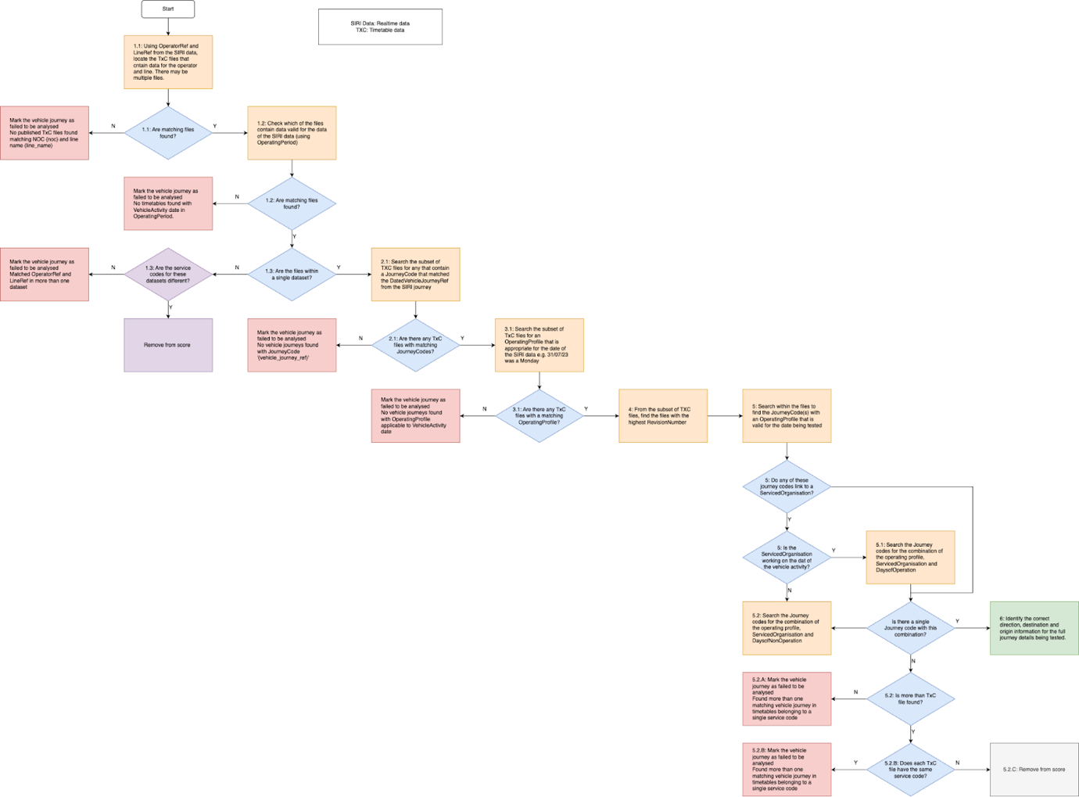

# Appendix B – Trip Adjustment Flowchart

Appendix B details the Trip Adjustment Flowchart employed in this study. The accompanying diagram provides a visual representation of how raw GPS and timetable data were processed and adjusted to accurately reflect the actual beginning of a bus trip and attempt to classify the trip accordingly. This process includes comparisons between trip initial direction, time, distance travelled versus the timetable data, ensuring that the reconstructed trips closely match the planned routes.

Several assumptions are made with the use of this method:

* The starting point of a trip must be precisely identified whether the bus starts early, late, or unfinished. At that point, the time and distance travelled is set to zero. The adjustment process is detailed in Appendix B.
* Time and distance travelled must be monotonic functions, i.e. accumulated time and distance in the future are always greater than those in the past.
* Instead of reconstructing the trip as a continuous function, this project employs linear interpolation [27] due to sufficient data granularity and only conducting trip-wise analysis, ignoring the identification of minute details like traffic signals or wait times at stops.
* The distance and time data are interpolated into 5m segments along the actual traversed path and referenced against the ideal planned trips.
* In cases of route diversion, it is assumed that the distance and time of the diversion route are similar to those of the normal route. This assumption is valid due to the imposed speed limit for buses [28], which does not allow them to diverge significantly from the planned route in a short amount of time. Additionally, buses are expected to revert to their planned path as soon as possible.

Readers should refer to the diagram to gain a clearer understanding of how the adjustment was performed and how it contributed to the reliability of the analysis results.

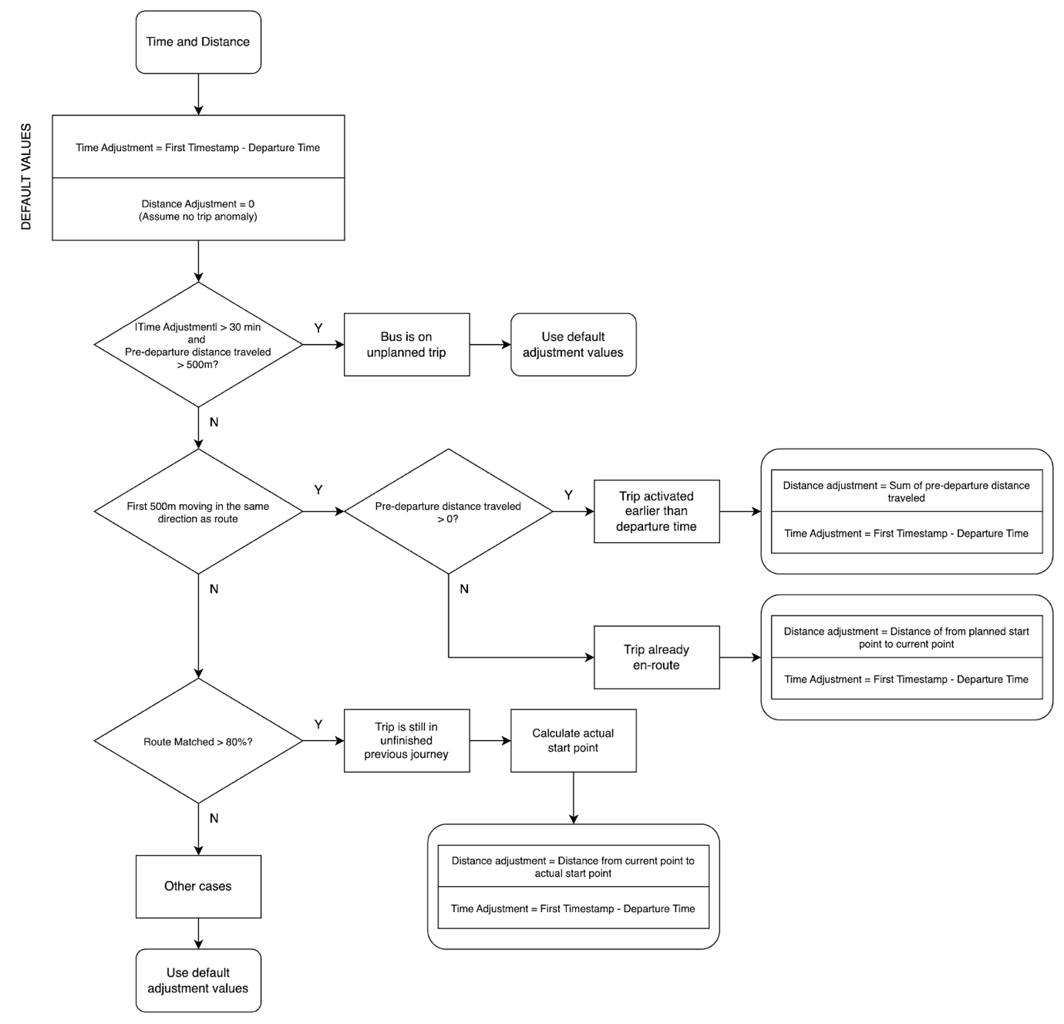

# Appendix C – Artefact Descriptions and User Guide

## Accessing the Dissertation Folder

The artefact can be accessed using this link with the passcode supplied at the front cover page of this report.

<https://tinyurl.com/kdo-uwe-sep24>

(Original link: <https://uweacuk-my.sharepoint.com/:f:/g/personal/ky2_do_live_uwe_ac_uk/EiALeHevJS5Dr5MnaNbktawBesOrCm8OkQ1YY0exG39PLA>)

## Folder Structure

Below you can find a structure of the folder and their descriptions.

* *Data-Driven Strategies for Bus Service Consistency - Ky Do.docx*: This file.
* *Data-Driven Strategies for Bus Service Consistency - Proposal - Ky Do.docx*: The original Proposal for this project.
* *Data-Driven Strategies for Bus Service Consistency - Ky Do.mov*: The 2-minute project summary video.
* *Artefact*: The folder containing the artefact, which is the result of the project, with code, processed data and zipped raw data.
  + *Project Reflection – Ky Do.docx*: Project Reflection file.
  + *bods_project*: The folder containing code for the artefact.
    - *README.md*: The file summarising the key content of the artefact and how to interact with it.
    - *00_main_report.ipynb*: The main reporting page.
    - *“data.zip”:* The zip file containing all the raw and processed data. To use some of the pre-processing code, please extract the *data* folder directly into the *Artefact* folder, with the same structure seen in the *README.md* file.

The main artefact is presented as an interactive and ready-to-use report in Jupyter Notebook form, which comprises of multiple steps.

One important and complex operation involves utilising the map-matching protocol, which requires the installation of Valhalla to run on a server. Docker was used in this project to run the server locally. To avoid unnecessary complications, all the raw data was pre-processed, but leave the raw data archived for any verification attempt by the reader.